**Writing Practice**

1. People vote for the President in November.

___________________________________________________________________

___________________________________________________________________

2. Columbus Day is in October.

___________________________________________________________________

___________________________________________________________________

3. Lincoln was president during the Civil War.

___________________________________________________________________

___________________________________________________________________

4. Kim Reynolds is the governor of Iowa.

___________________________________________________________________

___________________________________________________________________

5. It is important for all citizens to vote.

___________________________________________________________________

___________________________________________________________________

6. Susan B. Anthony fought for women’s rights.

___________________________________________________________________

___________________________________________________________________

7. Any citizen can vote once they are 18 years old.

___________________________________________________________________

___________________________________________________________________

8. Franklin Roosevelt (FDR) was President during the Great Depression.

___________________________________________________________________

___________________________________________________________________

**Reading Practice - World War II**

**World War II**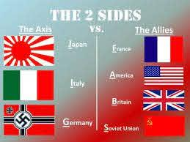

World War II began in 1939 when Germany invaded Poland. Germany was under the control of the dictator Adolf Hitler. Hitler was the leader of the Nazi Party. The war lasted from 1939 to 1945. 56 million people died directly because of the war. Germany and the Axis Powers (Germany, Italy, and Japan) lost the war; the Allies (Great Britain, France, the Soviet Union, and the United States) won.

**Pearl Harbor**

The United States did not enter World War II until 1941. On December 7, 1941, Japanese forces bombed the naval base at Pearl Harbor, Hawaii. President Franklin Roosevelt viewed this as an act of war. The United States entered World War II the next day, and remained fighting until the war ended.

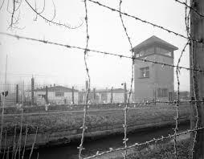

**The Holocaust**

Fighting was not the only cause of death in World War II. The Nazi Party was systematically killing all the Jews they could find as well, trying to get rid of all the Jews in the world. They put the Jews in Concentration Camps, where they would be forced to do labor, and eventually were killed. This event of killing the Jews is known as the Holocaust. The total number of Jews who died during the Holocaust is around 6 million.