**Writing Practice**

1. Citizens can vote.

___________________________________________________________________

___________________________________________________________________

2. Only Congress can declare war.

___________________________________________________________________

___________________________________________________________________

3. Freedom of speech is a right.

___________________________________________________________________

___________________________________________________________________

4. Abraham Lincoln was president during the Civil War.

___________________________________________________________________

___________________________________________________________________

5. Slavery was a cause of the Civil War.

___________________________________________________________________

___________________________________________________________________

6. The United States of America has 50 states.

___________________________________________________________________

___________________________________________________________________

7. A senator is elected for six years.

___________________________________________________________________

___________________________________________________________________

8. The President lives in the White House.

___________________________________________________________________

___________________________________________________________________

**Reading Practice - The Civil War**

**The Civil War**

The Civil War was the war fought in the United States between the North and the South. The war lasted four years. One of the causes of the Civil War was slavery. The South wanted to keep slavery, and the North wanted to get rid of slavery. The North won the war, and slavery ended. Three new amendments to the Constitution were added after the Civil War; the 13th, 14th, and 15th Amendments. These amendments are commonly referred to as the ‘Slave Amendments’.

**The Emancipation Proclamation**

The Emancipation Proclamation freed the slaves. President Lincoln signed and delivered the Emancipation Proclamation in September, 1863. It said that starting on January 1, 1864, all southern slaves were now free. Slavery was ended.

**Abraham Lincoln**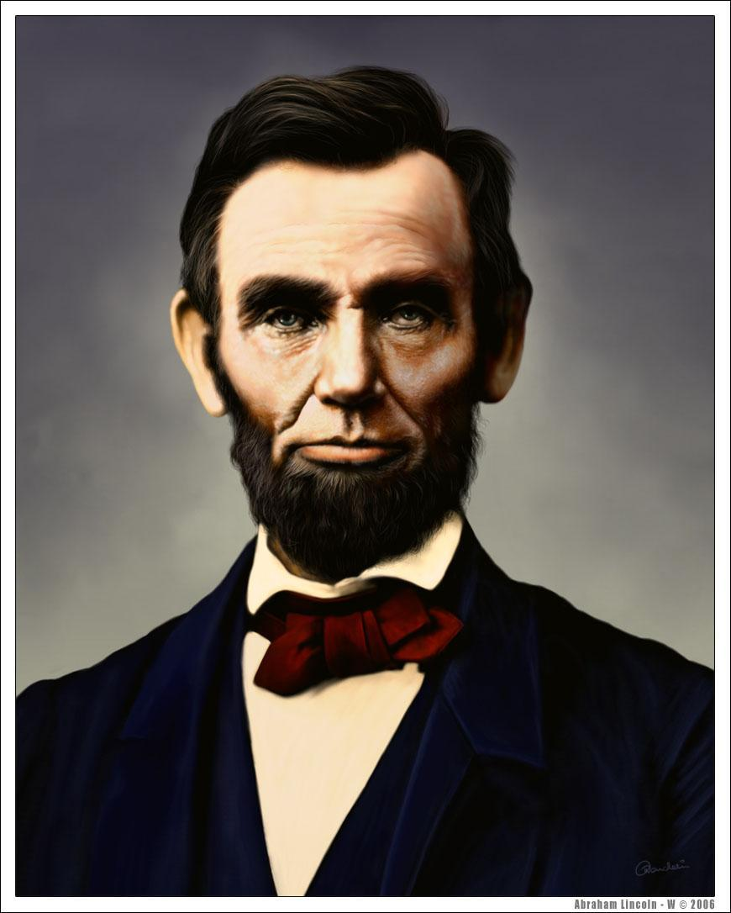

President Lincoln was president during the Civil War. He was shot and killed 5 days after the end of the war. He was watching a play in the theater with his wife. President Lincoln is best known for uniting the country, freeing the slaves, and leading the country during the Civil War.