**Writing Practice**

1. The President is elected every four years.

___________________________________________________________________

___________________________________________________________________

2. The President lives in the White House.

___________________________________________________________________

___________________________________________________________________

3. They want to vote.

___________________________________________________________________

___________________________________________________________________

4. The senators from Iowa are Chuck Grassley and Joni Ernst.

___________________________________________________________________

___________________________________________________________________

5. Congress meets in Washington, D.C.

___________________________________________________________________

___________________________________________________________________

6. Our government is divided into three branches.

___________________________________________________________________

___________________________________________________________________

7. A senator is elected for six years.

___________________________________________________________________

___________________________________________________________________

8. The Governor of Iowa is Kim Reynolds.

___________________________________________________________________

___________________________________________________________________

**Reading Practice - Executive Branch**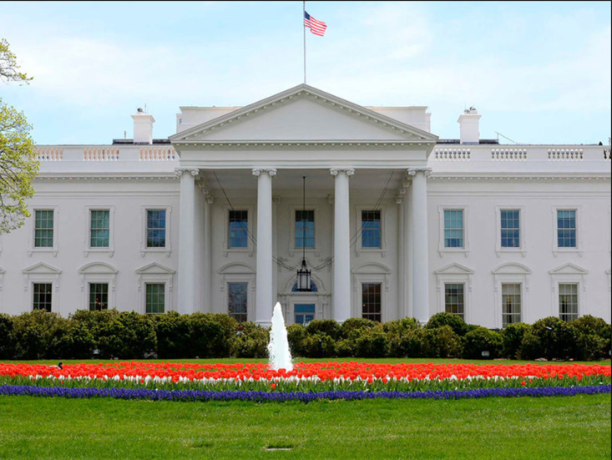

**The Executive Branch**

The government of the United States of America is divided into three branches. The branches are executive, legislative, and judicial. The executive branch includes the President of the United States, the Vice President, and the Cabinet, as well as the many government employees in various agencies.

**The President**

The President has several powers that only belong to that office. The President signs or veto laws that are written and passed by Congress. Because of the checks and balances system a Presidential veto may be overturned with a two-thirds majority in both the House and Senate. When there is a vacancy in the Supreme Court, the President nominates a new person for approval by the Senate. The President is also the Commander-in-Chief of the military.

**The Vice President**

The Vice President has limited powers. He can vote in the Senate, but only to break ties. The Vice President is a member of the President’s Cabinet, a group that advises the President. If the President is not able to continue in office, the Vice President would become President.

**The Cabinet**

The Cabinet is selected by the President, with the consent of the Senate. When a new president is elected, a new cabinet is appointed. Cabinet members lead major government departments and advise the President regarding issues related to their department. Cabinet positions include Secretary of Education, Agriculture, Defense, Education, and Transportation.

**Reading Practice - Iowa**

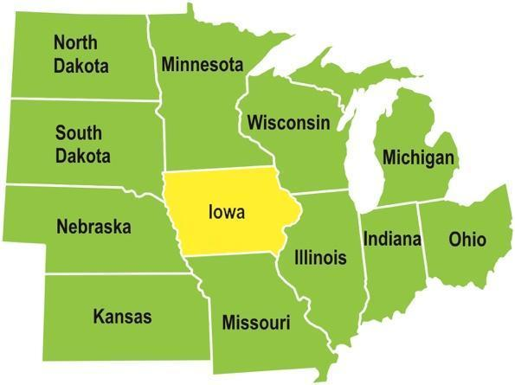

**Location**

Iowa is a state in the middle area of the United States; the region is called “the Midwest.” Iowa is bordered by the Mississippi River to the east and the Missouri River to the west. It is bordered by six states; Wisconsin to the northeast, Illinois to the east, Missouri to the south, Nebraska to the west, South Dakota to the northwest and Minnesota to the north.

**History**

The first Europeans to explore Iowa were Jacques Marquette and Louis Jolliet who traveled the Mississippi River in 1673. The area of Iowa was claimed for France and remained a French territory until 1763. In 1803 the United States government purchased a large amount of land from France. The transaction is known as the Louisiana Purchase. Iowa was part of the Louisiana Purchase. Because of this history Iowa’s state flag is patterned after the flag of France. On December 28, 1846, Iowa became the 29th state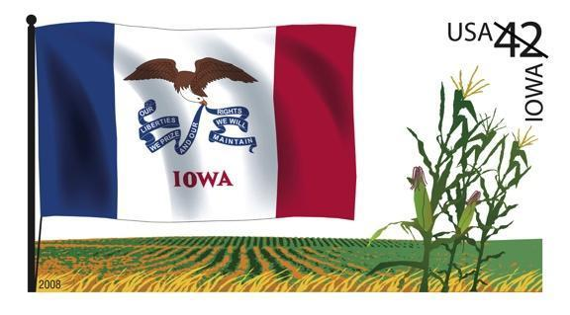

**Government**

The capital and largest city in Iowa is Des Moines. The governor leads the executive branch of the Iowa; her name is Kim Reynolds. The legislative branch is called the Iowa General Assembly. It is made up of a House of Representatives and a Senate. Iowa also has a judicial branch; the Supreme Court of Iowa is the highest court in Iowa.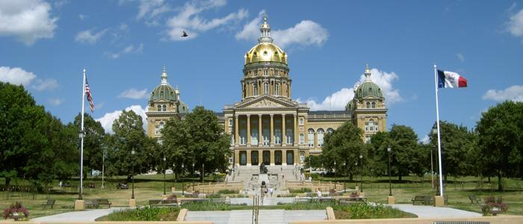

Iowa has 99 counties. Each county has a county seat with a courthouse. Columbus Junction is located in Louisa County. The county seat of Louisa County is Wapello.