Writing Practice

1. Many people come to America for freedom.

1. Washington was the first president.

1. The Constitution is the supreme law of our land.

1. Our government is divided into three branches.

1. The House and Senate are parts of Congress.

Reading Practice

U.S. Government: The Legislature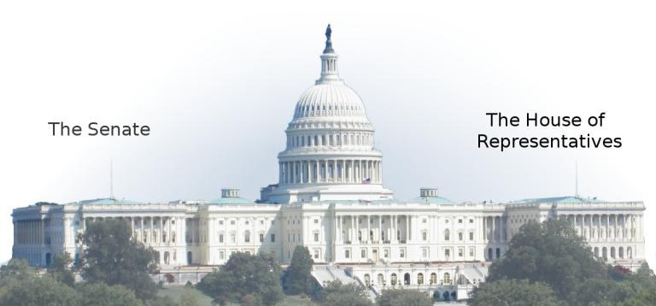

**The Legislative Branch**

The Legislative Branch is also called Congress. It is made up of the Senate and the House of Representatives. Congress makes Federal laws.

Citizens vote for the U.S. senators and representatives from their state. Senators represent all the people of their state and serve for six years. Representatives represent a district or part of a state and they serve for two years.

**The Senate**

There are 100 senators in the Senate. Each state has two senators. Each senator is elected for a six-year term. A senator must be at least 30 years old, a U.S. citizen for at least 9 years, and a resident of the state represented. The Vice President of the United States serves as President of the Senate and makes the decisive vote in the event of a tie in the Senate.

Iowa’s senators are Chuck Grassley and Joni Ernst.

**The House of Representatives**

There are 435 voting members in the House of Representatives. The 435 seats are divided among the 50 states based on their population. California has the highest population and the most representatives; there are 53 representatives from California. There are seven states that have only one representative each. The presiding officer is elected by the representatives and is called the Speaker of the House. The current Speaker of the House is Nancy Pelosi.

Iowa has four representatives. Our current representative in District 2 is Dave Loebsack.