Writing Practice

|  |
| --- |
| 1. I want to be an American citizen. |
| 1. The colors of the flag are red, white and blue. |
| 1. The White House is in Washington, D.C. |
| 1. Presidents’ Day is in February. |
| 1. Labor Day is in September.   **Practice saying these sentences out loud between now and Session 3. |

Reading Exercise

Revolution and Independence

England has thirteen colonies along the Atlantic, or east coast, of North America. They were New Hampshire, Massachusetts, Rhode Island, Connecticut, New York, New Jersey, Pennsylvania, Delaware, Maryland, Virginia, North Carolina, South Carolina, and Georgia. These colonies later became the first 13 states.

The settlers had to obey the laws of the King of England. Due to these laws, settlers could not trade with other countries. They had to send the products they produced to England, and they could only buy products from England. The settlers had to pay high taxes to England. They had no representation, no one to act or speak on their behalf in England, to control the amount of taxes charged or how the tax money was used. They had taxes without representation.

Many settlers did not like these laws. When the king imposed a high tea tax, the settlers in Boston, Massachusetts, got angry. Some of them dressed as Native Americans to disguise themselves and threw tea from a ship in Boston’s harbor into the water. This event was called the Boston Tea Party.

The people of the colonies got angry. Representatives of each colony met in Philadelphia, Pennsylvania, in 1774. This meeting was called the First Continental Congress. The representatives decided (1) to ask the king to modify some of his laws, (2) to end all trade with England, and (3) to prepare for war. In March 1775, Patrick Henry said “Give me freedom or give me death” to a group of representatives gathered in Virginia.

In May 1775, the colonists held a Second Continental Congress at Independence Hall in Philadelphia, Pennsylvania. The representatives decided that they wanted to be independent of England. They asked Thomas Jefferson to write the Declaration of Independence.

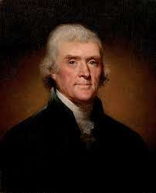

Thomas Jefferson was the principal author of the Declaration of Independence.

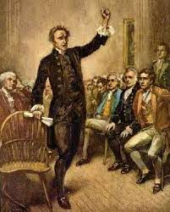

Patrick Henry speaks against the laws of the King of England.